Dear Faculty,
The Faculty Member Dashboard can be found at,
https://ecbg.fa.us2.oraclecloud.com/analytics/saw.dll?Portal&PortalPath=%2Fshared%2FCustom%2FRU%20Saved%20Queries%2FProjects%2FFaculty%20Member%20Dashboard
Please bookmark this site for future visits.

Log in Instructions:
- Sign in using your netid and password
- One left side, select your name and hit apply
- Summary sheet should change to only show your financial information
- Choose the gear icon on top right of the screen:
- Choose Save Current Customization
- Assign it a meaningful name
- Check “Make this my default for this page”
- Hit OK

Understanding the financial report:

Summary section:
- Shows a quick summary of each of your projects/tasks.
- The numbers under the Budget, Revenue, Raw Cost, Burden Cost, Cost, and Commitments are hyperlinked. This allows you to see the transactions that comprise that number.
- To see the transactions that comprise the hyperlinked number,
  - Click on the number
  - Click on Drill to <specific> Detail
  - New window opens up with detail of all transactions that add up to that number.
- The highlighted columns direct you to the correct columns to see your available balance with or without commitments (see definition below).
- Choose Export to export the summary in one of the different formats provided so that you can manipulate the data in any way you like.
Cost Detail section:
- Allows you to only look at that cost transactions in four different ways.
- Choose Export to export the cost detail in one of the different formats provided so that you can manipulate the data in any way you like.

Committment Detail section:
- Allows you to only look at that commitment transactions.
- Choose Export to export the cost detail in one of the different formats provided so that you can manipulate the data in any way you like.

Project Budget Report section:
- Allows you to only look at that budget for those projects that were budgeted (primarily grant accounts) by project number.
- Choose Export to export the cost detail in one of the different formats provided so that you can manipulate the data in any way you like.

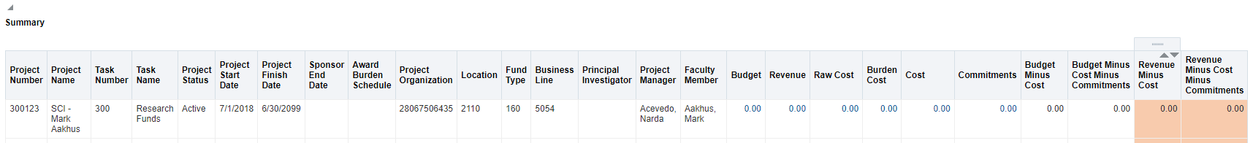
Here is a screen shot of the columns found on the financial report with the definitions below:

- Project Number: This is basically your account number.
- Project Name: Name of project. Unless a grant, this is usually the faculty member’s name
- Task Number: If you have different sources of funds (e.g. start-up funds, research funds, Byrne funds, etc.) the task number is how we separate the different sources of funds.
- Task Name: Identifies the specific source of funds.
- Project Status: This indicates the status of that task. Those with grants may see “pending close” as the grant is coming to an end.
- Project start date: Date project was created
- Project Finish Date: Date project is scheduled to end at the university (takes into account the 90 days provided to close our grant projects.
- Sponsor End Date: Date project is scheduled to end with sponsor (normally grants)
- Award Burden Schedule: This is the F&A rate for the grant.
- Project Organization: This is used to identify what unit these funds fall under (28067506435=SCI Dean’s Office)
- Location: identifies the area for which you are providing service (2110 = New Brunswick NonHealth Sciences Campus)
- Fund Type: Identifies the funding source used to acquire goods and services (Unrestricted, Restricted, Endowment).
- Business Line: Identifies the specific line of business (or mission) being offered.
- Principal Investigator: Person responsible for the research and fund management (normally grants)
- Project Manager: Staff responsible for administrative tasks for project.
- Faculty Member: Faculty member responsible for this account/project in question.
- Budget: Funds enter in system as budget.
- Revenue: Funds received from outside sources
- Raw Cost: Direct expenses charged to project.
- Burden Cost: Indirect expenses charged to project (F&A expenses normally charged to grants)
- Cost: Sum of both direct and indirect expenses
- Commitments: purchase orders created, but not yet paid out to vendor.
- Budget Minus Cost: Remaining balance of budget reduced by sum of cost (GRANTS).
- Budget Minus CostMinus Commitments: Remaining balance of budget reduced by sum of both cost and commitments (GRANTS).
- Revenue Minus Cost: Remaining balance of project (unbudgeted) reduced by sum of cost (FACULTY FUNDS).
- Revenue Minus Cost Minus Commitments: Remaining balance of project (unbudgeted) reduced by sum of cost and commitments (FACULTY FUNDS).

